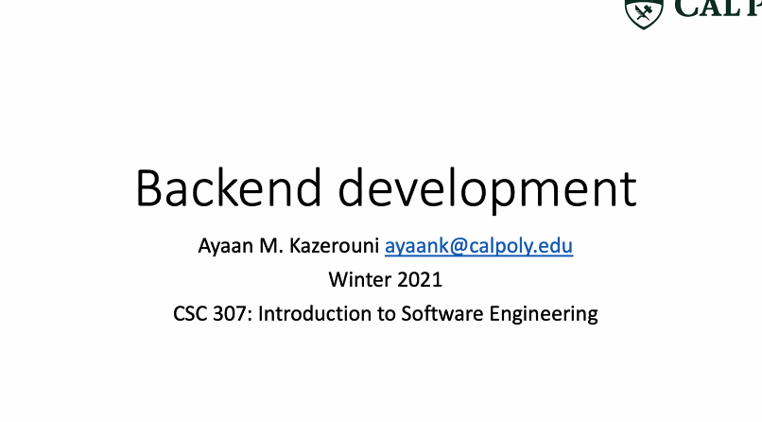

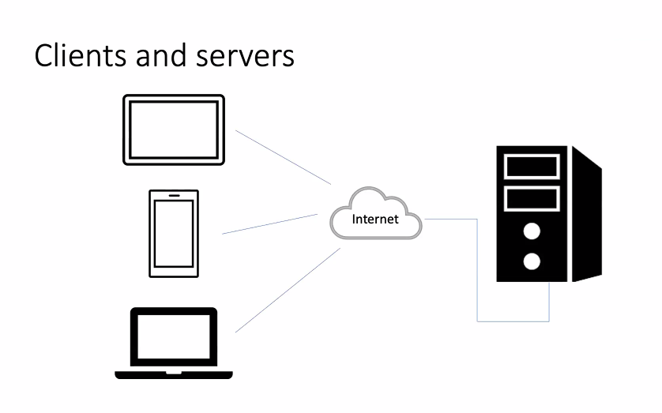

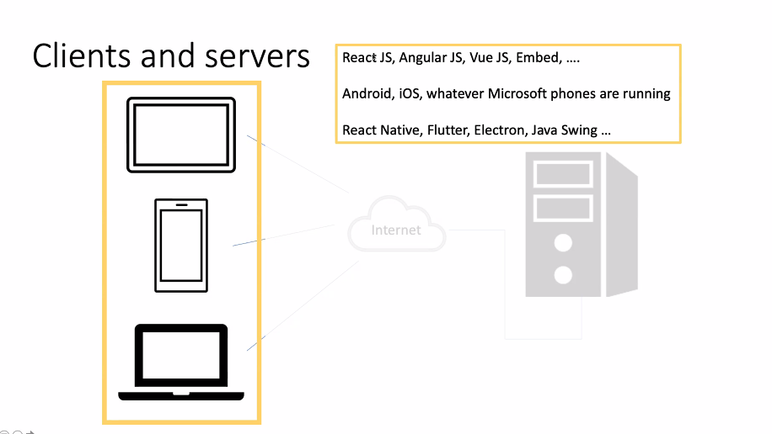

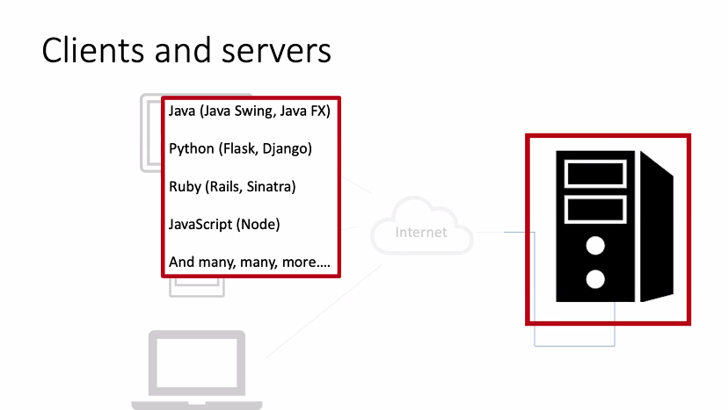

API = abstraction of your database. What the client needs to see and easy to access. Abstractions over other services.

Exposes certain kind of data to certain users. So exposing functions to clients. Clients having various functions they have access to.

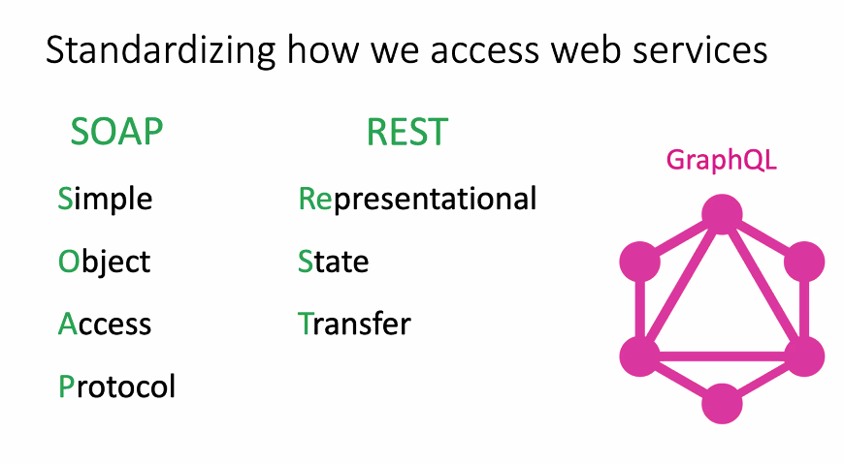



These are based on resources, so you know how to develop models for you resources. But don’t want 1 to 1 mapping. You are not just exposing your database to the client so your url should be simple and not complicated.

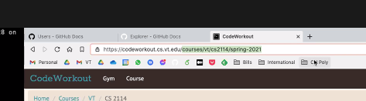

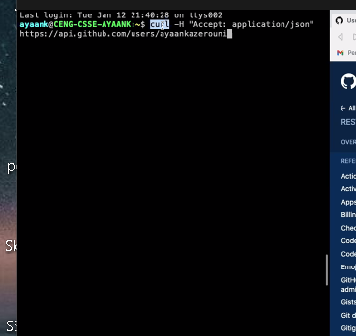

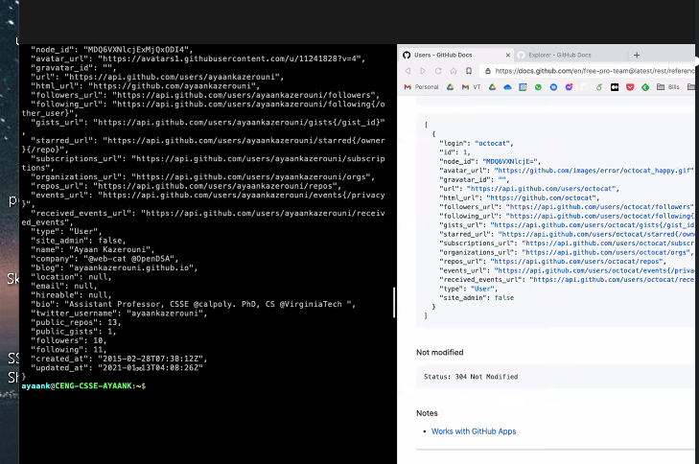

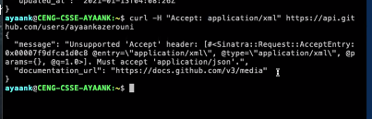

Example of unsupported xml.

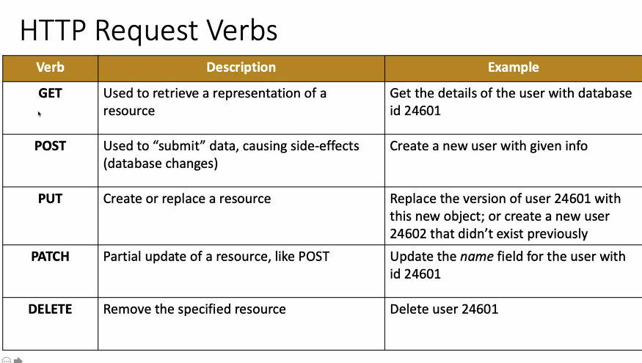

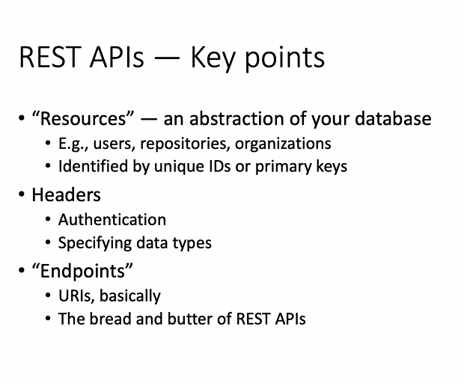

Sql database is normalized when everything reachable / accessible.

GraphQL orders your data into a schema. Users would have “edges” to other users or repositories. Helps you organize your api into a graph of resources.

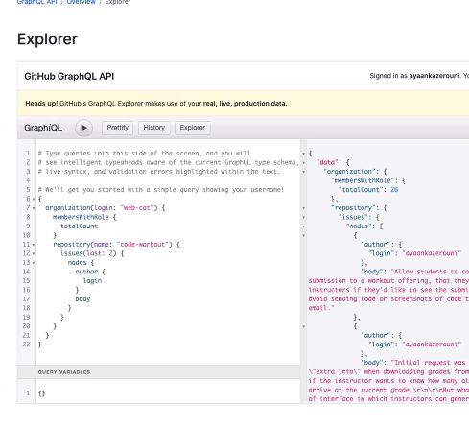

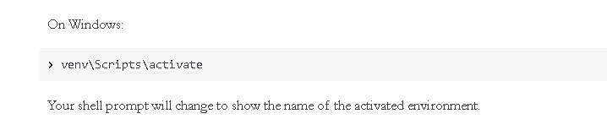

set FLASK_APP=sample_backend.py

set FLASK_ENV=development

flask run

Run in python directory

Making in new folder:

python3 -m venv venv

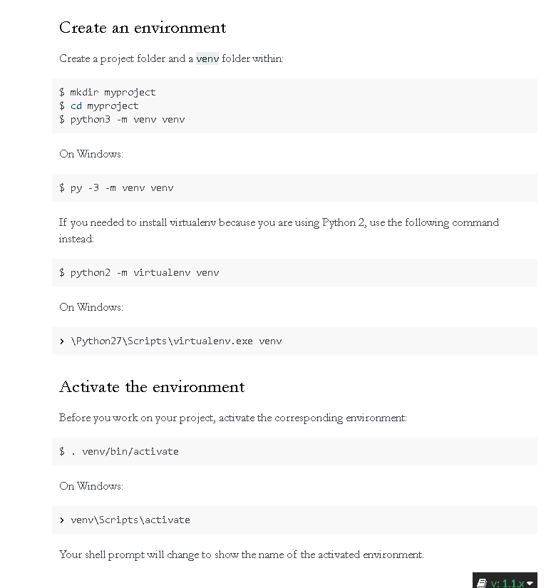

NPM INSTALL  
  
when need to re-install node packages